LAB 9: Wireless Network Configuration and Packet Inspection Using Cisco Packet Tracer
OBJECTIVES:
- To set up a wireless router and create a functional WLAN in Cisco Packet Tracer.
- To connect wireless clients and enable automatic IP configuration through DHCP.
- To implement WPA2 security to ensure protected wireless communication.

THEORY:
A wireless network allows devices to exchange data without the need for physical cabling, using radio frequency signals for communication. In this lab, a wireless router is configured to establish a Wireless Local Area Network (WLAN). The router provides connectivity to wireless clients, assigns IP addresses dynamically using DHCP, and ensures secure access.
Each wireless network is identified by a unique Service Set Identifier (SSID), which allows client devices to recognize and connect to the correct network. For security purposes, WPA2-Personal encryption with AES is configured. This security mechanism prevents unauthorized users from accessing the network by requiring a valid passphrase.
Wireless devices connect by selecting the configured SSID and entering the correct security key. Once connected, DHCP automatically provides the necessary IP configuration parameters.
Packet analysis is performed using Simulation Mode in Cisco Packet Tracer. By observing packets such as DHCP, ARP, and general data frames, users can understand how devices obtain IP addresses, establish communication, and exchange information. Packet inspection is also useful for identifying errors and verifying that the network operates correctly in a wireless environment.
NETWORK TOPOLOGY:
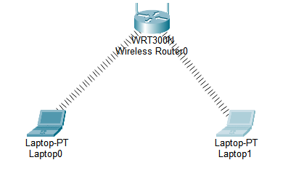
PROCEDURE:
Wireless Router Setup
Step 1: Initial Configuration
- Select the Wireless Router device.
- Open the GUI tab and navigate to Setup.
- Enter the following network details:
  - IP Address: 192.168.0.1
  - Subnet Mask: 255.255.255.0
  - DHCP Server: Enable this option
This configuration allows the router to function as the gateway and automatically distribute IP addresses to connected devices.

Step 2: Configure Wireless Settings
- Move to Wireless → Basic Wireless Settings.
- Set the required parameters as follows:
  - Network Mode: Mixed
  - SSID (Network Name): HCOE
  - Channel: Auto
- Click Save Settings to apply the configuration.
The SSID will now be visible to nearby wireless devices.

Step 3: Apply Wireless Security
- Open Wireless → Wireless Security.
- Configure the security settings:
  - Security Mode: WPA2-Personal
  - Encryption Type: AES
  - Passphrase: hcoe@123
- Save the changes.
This ensures that only users with the correct password can access the wireless network.
OBSERVATIONS:
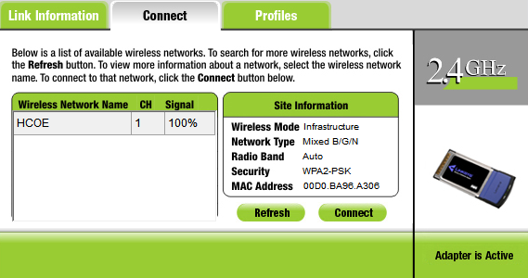
RESULT:
The wireless network was configured successfully using the WRT300N router. The network name (SSID) HCOE was created and protected using WPA2-Personal security with AES encryption. The router, operating at the gateway address 192.168.0.1, distributed IP addresses automatically through DHCP. Laptop0 and Laptop1 were able to detect the wireless network, connect using the correct passphrase, obtain valid IP configurations, and communicate effectively via the router.
DISCUSSION:
This experiment highlighted the practical implementation of a secure wireless LAN. The DHCP feature simplified network setup by dynamically assigning IP addresses to wireless clients. The use of WPA2-Personal security enhanced protection by ensuring that only authorized users with the correct password could access the network. Observing packet flow in simulation mode provided better insight into how devices associate with the router, request IP addresses, and exchange data. The lab also strengthened understanding of wireless configuration and basic troubleshooting methods.
CONCLUSION:
The objectives of establishing and securing a wireless network were achieved successfully. The SSID was configured properly, security measures were applied using WPA2 encryption, and DHCP ensured automatic IP allocation. Wireless devices connected securely and communicated without issues, demonstrating effective wireless network setup and management in Cisco Packet Tracer.

